Study Guide for Exam One
Description of Exam One
Total Points: 100
Time: 70 Minutes
Resources: Anything except help from other people or AI/LLM (ChatGPT, etc)
Sections:
Multiple Choice:
- Points: 45 – 3 points each
- Number of Questions: 15 questions
- Suggested Time: 20 minutes

Short Answer
- Points 25 – 5 points each
- Number of Questions: 5
- Suggested Time: 15 minutes

Sentence Labeling
- Points: 30 – 5 points each
- Number of Questions: 6 diagrams
- Suggested Time: 25 minutes

Bonus Sentence Diagrams
- Points: 15 – 3 points each
- Number of Questions: 5
- Suggested Time: 10 minutes

Section A: Multiple Choice
Question One: Which of these is the best example of a prescriptive rule?_
Answer:_____
- In English, you can make most adjectives into adverbs by adding an -ly sound to the end
- In English, the direct object usually comes after indirect object
- In English, good writers never split infinitives
- In English, many nouns are made plural by adding an s sound to the end of the word

Question Two: Which of these words falls in an “Open Class”?
Answer:_____
- Which
- Sticky
- Upon
- Hers

Question Three: In the sentence below, which of these words is functioning as an adjective? ____
Answer:_____
Sentence: To this day, her stubborn mother refuses to truly apologize.
- Stubborn
- This
- Truly
- Apologize

Question Four: In the sentence below, which of these words is functioning as a determiner?
Answer:_____
Sentence: Typically, my cat sleeps peacefully on the top of the couch with her head on her little grey paws.
- Top
- Little
- Typically
- Her

Question Five: Which of these words is made up of exactly two morphemes? (3 pts)
- Sadly
- Predetermined
- Unconditional
- Tornado

Question Six: Divide this word into all of its separate morphemes. Identify each morpheme as “free” or “bound.” (5 pts)
Word: “preheated”
- Pre- Free
- Heat – Bound
- -ed - Free

Question Seven: Divide this word into all of its separate morphemes. Identify each morpheme as “free,” “derivational,” or “inflectional” (5 pts)
Word: “babysitters”
Baby – free
Sit – Free
-er – Derivational
-s - Inflectional

Sentence Labeling: 30 points
On the following pages, you will find five sentences. For each sentence, label the part of speech for every word in the sentence by writing the part of speech below the word in the table. In some cases, words may fit more than morphological part of speech (form). Please label the word based on its syntax (function) as it is used in the sentence provided.
If you want to save space, you may use these abbreviations.
- Noun = N
- Verb = V
- Adjective = Adj
- Adverb = Adv
- Preposition = Prep
- Determiner = Det

Bonus: For up to three points of bonus each (15 total) diagram each of these sentences.
Follow the diagraming system we have been using in class. Include a “phrase level” for all word types except determiners.

Question Eight:
Sentence: Two valuable books fell on the floor.
Two | Valuable | Books | Fell | On | The | Floor
Det | Adj | N | V | Prep | Det | N

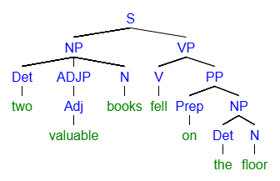

Question Nine:
Sentence: Kimba always excelled at his old school.
Kimba | Always | Excelled | At | His | Old | School
N | Adv | V | Prep | Det | Adj | N

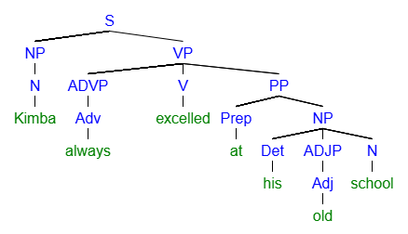

Question Ten: Please diagram this sentence.
Sentence: The subtle question echoed across the empty room.
The | Subtle | Question | Echoed | Across | The | Empty | Room
N | Adj | N | V | Prep | Det | Adj | N

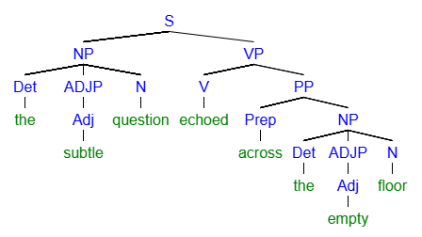
Question Eleven: Please identify this sentence type and then diagram this sentence.
Sentence: One clerk with a white beard silently scribbled.
One | Clerk | With | A | White | Beard | Silently | Scribbled
Det | N | Prep | Det | Adj | N | Adv | V

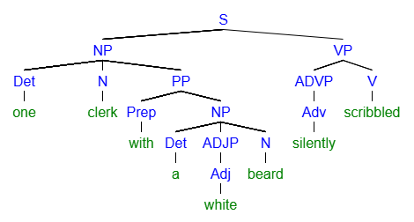

Question Twelve: Please identify this sentence type and then diagram this sentence.
Sentence: Some naughty terriers yap for food in their bowl.
Some | Naughty | Terriers | Yap | For | Food | In | Their | Bowl
Det | Adj | N | V | Prep | N | Prep | Det | N

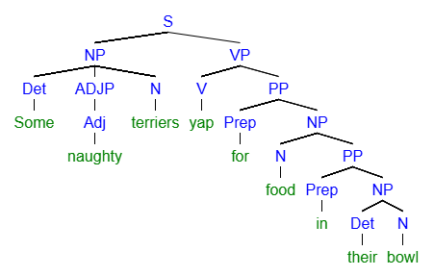
Note: this diagram indicates the food is in the bowl. We would use a different diagram to indicate the terriers were in the bowl.

